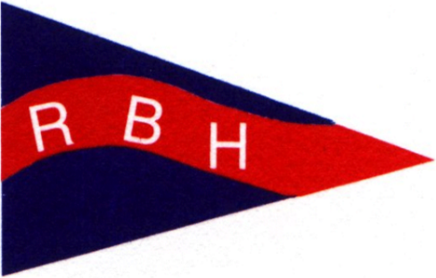
2023 RED BROOK HARBOR YACHT CLUB
APPLICATION & RENEWAL FORM
Date:

NAMES: CAPTAIN ________________________________ FIRST MATE ___________________________________

CURRENT MEMBERS:
Renewal Fee: $75.00
Please review your information that is listed in the 2022 Membership Directory.
Please check if there are no changes to your 2023 information. You do not need to complete the remainder of this form.
NEW MEMBERS: Sponsor: ___________________________________________________________
Application Fee: $105.00 (includes RBHYC burgee)

STREET ADDRESS _______________________________________________________ P.O. BOX _______________
CITY ___________________________________________ STATE _________________ ZIP_____________________
HOME PHONE _________________________ CELL PHONE(S) ___________________________________________
WINTER ADDRESS: _______________________________________________________ P.O. BOX _______________
CITY ____________________________________________ STATE _________________ ZIP_____________________
E-MAIL ADDRESS(ES) ______________________________ _____________________________________________
BOAT NAME _________________________________________________ MAKE ______________________________
LENGTH _____________ SAIL OR POWER ________________ RIG ____________________ SAIL # ____________
MOORING LOCATION __________________________________________________MMSI # ____________________
ADDITONAL INFO :_________________________________________________________________________________
Return this form (if changes) and your paper check or e-check, payable to “Red Brook Harbor Yacht Club” or “RBHYC”, to the Treasurer
Sue Flanagan
474 Main St
Cotuit, MA 02635 Revised 10/22/2022

